|  |  |  |  |
| --- | --- | --- | --- |
|  | | | |
| **Expt. No:** | | **10** | **Binary to Gray Code and Gray Code to Binary** |
|  | | |
| **Date:** | **26/10/21** | |
|  | | | |

Name: Krishna Pandey

Admn no: U20CS110

**Aim:**  To design and implement three-bit binary to gray and three-bit gray to binary code converter using Multi-Sim.

**SOFTWARE TOOLS / OTHER REQUIREMENTS:**

1. Multisim Simulator/Circuit Simulator

# Theory:

**The reflected binary code or Gray code is an ordering of the binary numeral system such that two successive values differ in only one bit (binary digit). Gray code also known as reflected binary code, because the first (n/2) values compare with those of the last (n/2) values, but in reverse order.**

**Gray code is not weighted that means it does not depends on positional value of digit. This cyclic variable code that means every transition from one value to the next value involves only one bit change.**

**Gray codes are very useful in the normal sequence of binary numbers generated by the hardware that may cause an error or ambiguity during the transition from one number to the next. So, the Gray code can eliminate this problem easily since only one bit changes its value during any transition between two numbers.**

# BINARY TO GRAY CODE CONVERSION:

**Let *B0, B1, B2* be the bits representing the binary numbers, where *B0* is the LSB and *B2* is the MSB, and let *G0, G1, G2* be the bits representing the gray code of the binary numbers, where *G0* is the LSB and *G2* is the MSB.**

**The truth table for the conversion of three-bit binary to gray code is given below.**

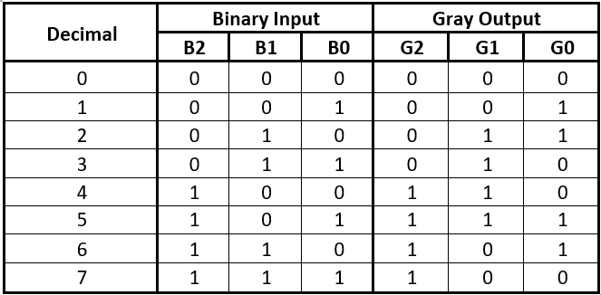

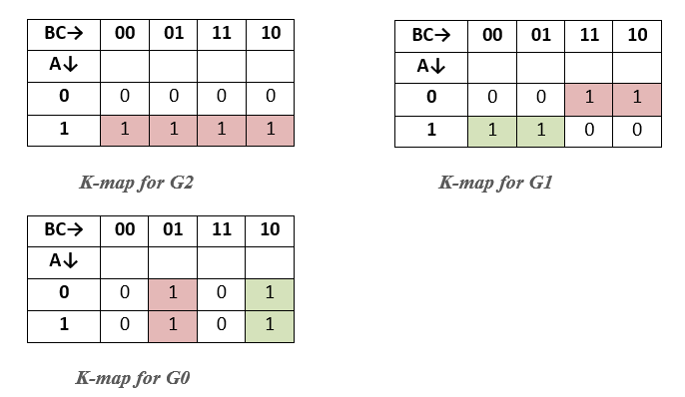

**Corresponding minimized Boolean expressions for Gray code are:**

***G2 = B2***

***G1 = B2’*B1 + B1’*B2***

***G0 = B1’*B0 + B1*B0’***

# GRAY TO BINARY CODE CONVERSION:

**Let *B0, B1, B2* be the bits representing the binary numbers, where *B0* is the LSB and *B2* is the MSB, and let *G0, G1, G2* be the bits representing the gray code of the binary numbers, where *G0* is the LSB and *G2* is the MSB.**

**The truth table for the conversion of three-bit binary to gray code is given below.**

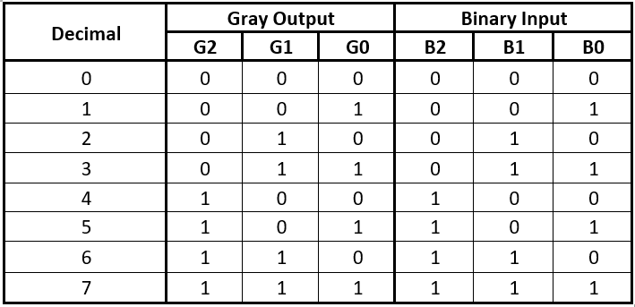

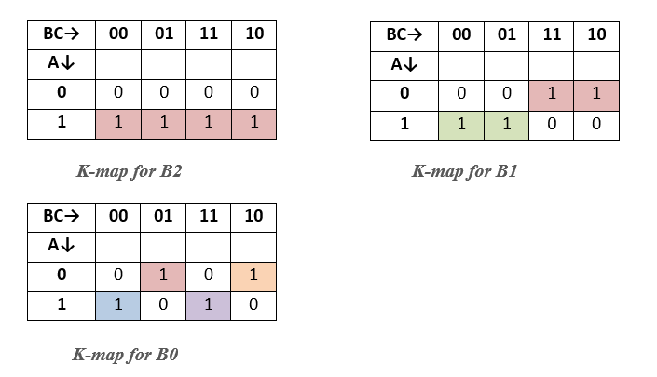

Corresponding minimized Boolean expressions for Gray code are:

***B0 = G2***

***B1 = G2’*G1 + G1’*G2***

***B0 = G2’*(G1’*G0 + G1*G0’) + G2*(G1’*G0’ + G1*G0)***

***= G2’* (G1***  ***G0) + G2*(G1* ⊙ *G0) B0 = G0***  ***G1***  ***G2***

# BINARY TO GRAY CODE CONVERSION:

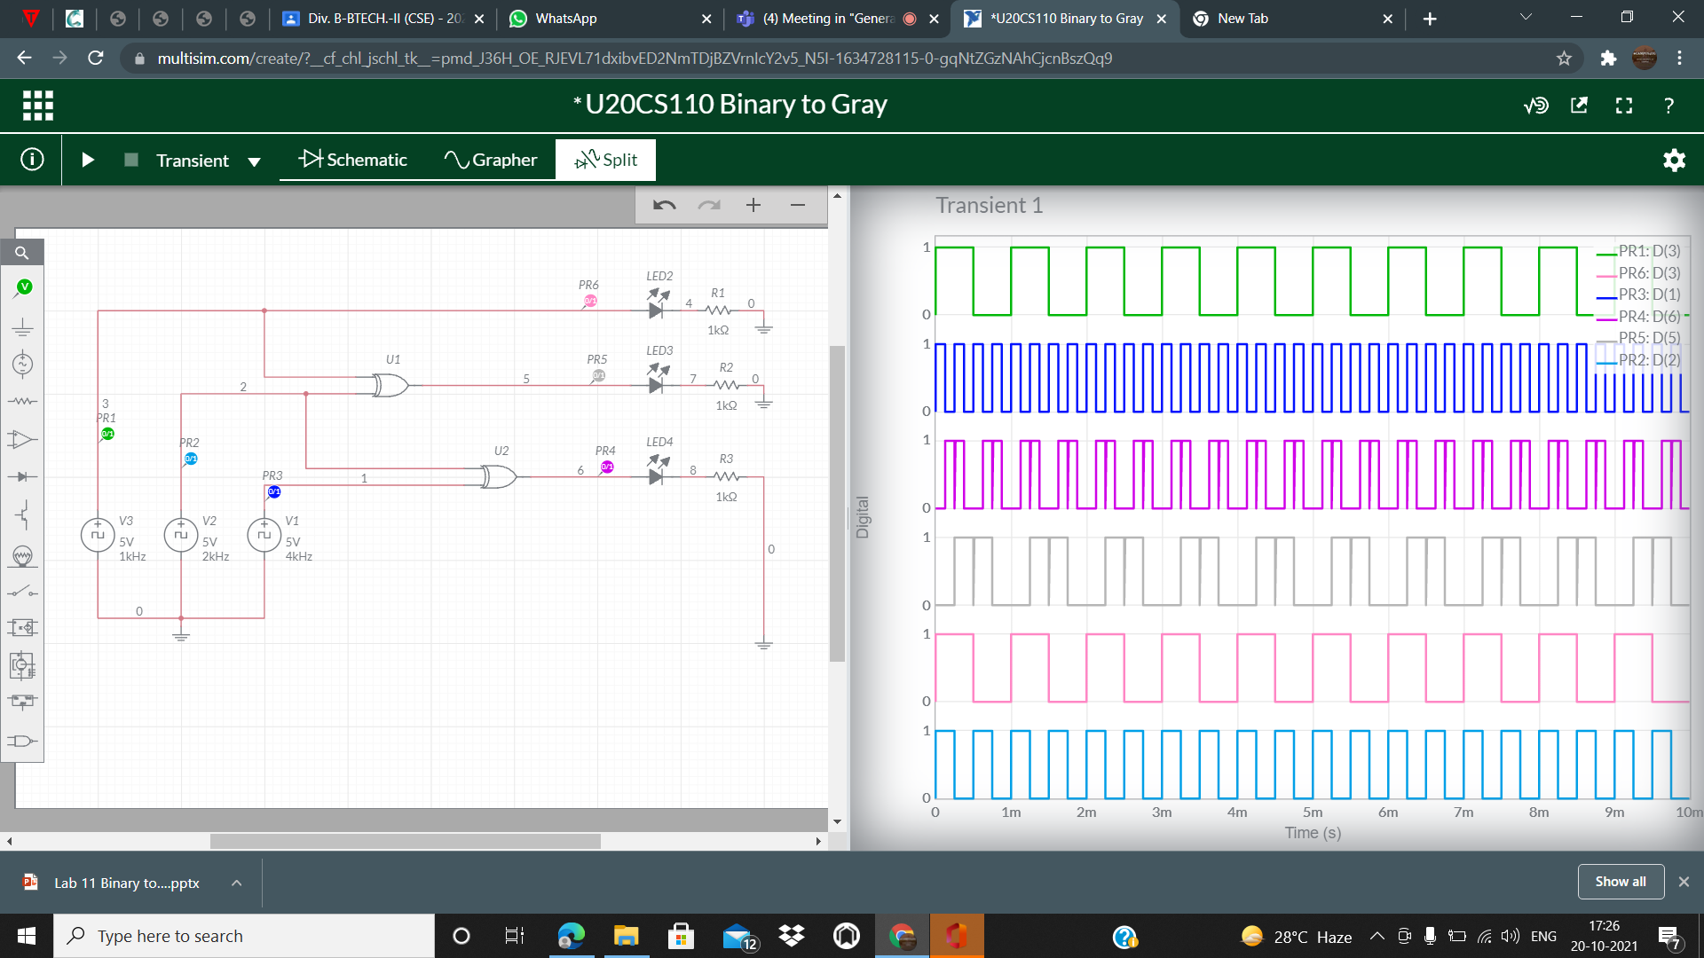

# CIRCUIT/CONNECTION DIAGRAMS (FROM MULTISIM)\

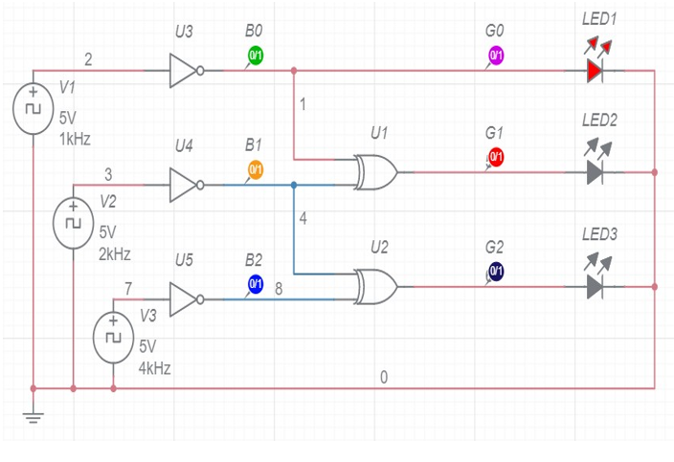

**WAVEFORMS (FROM MULTISIM)**

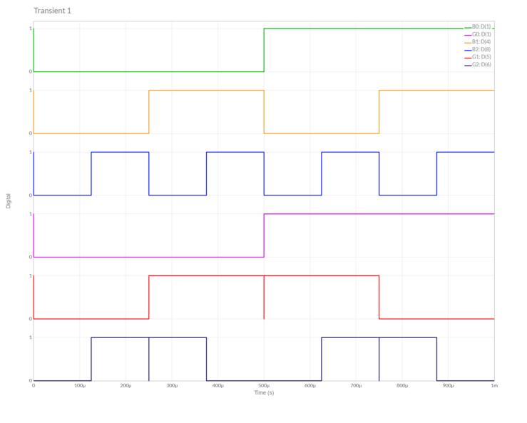

**GRAY TO BINARY CODE CONVERSION:**

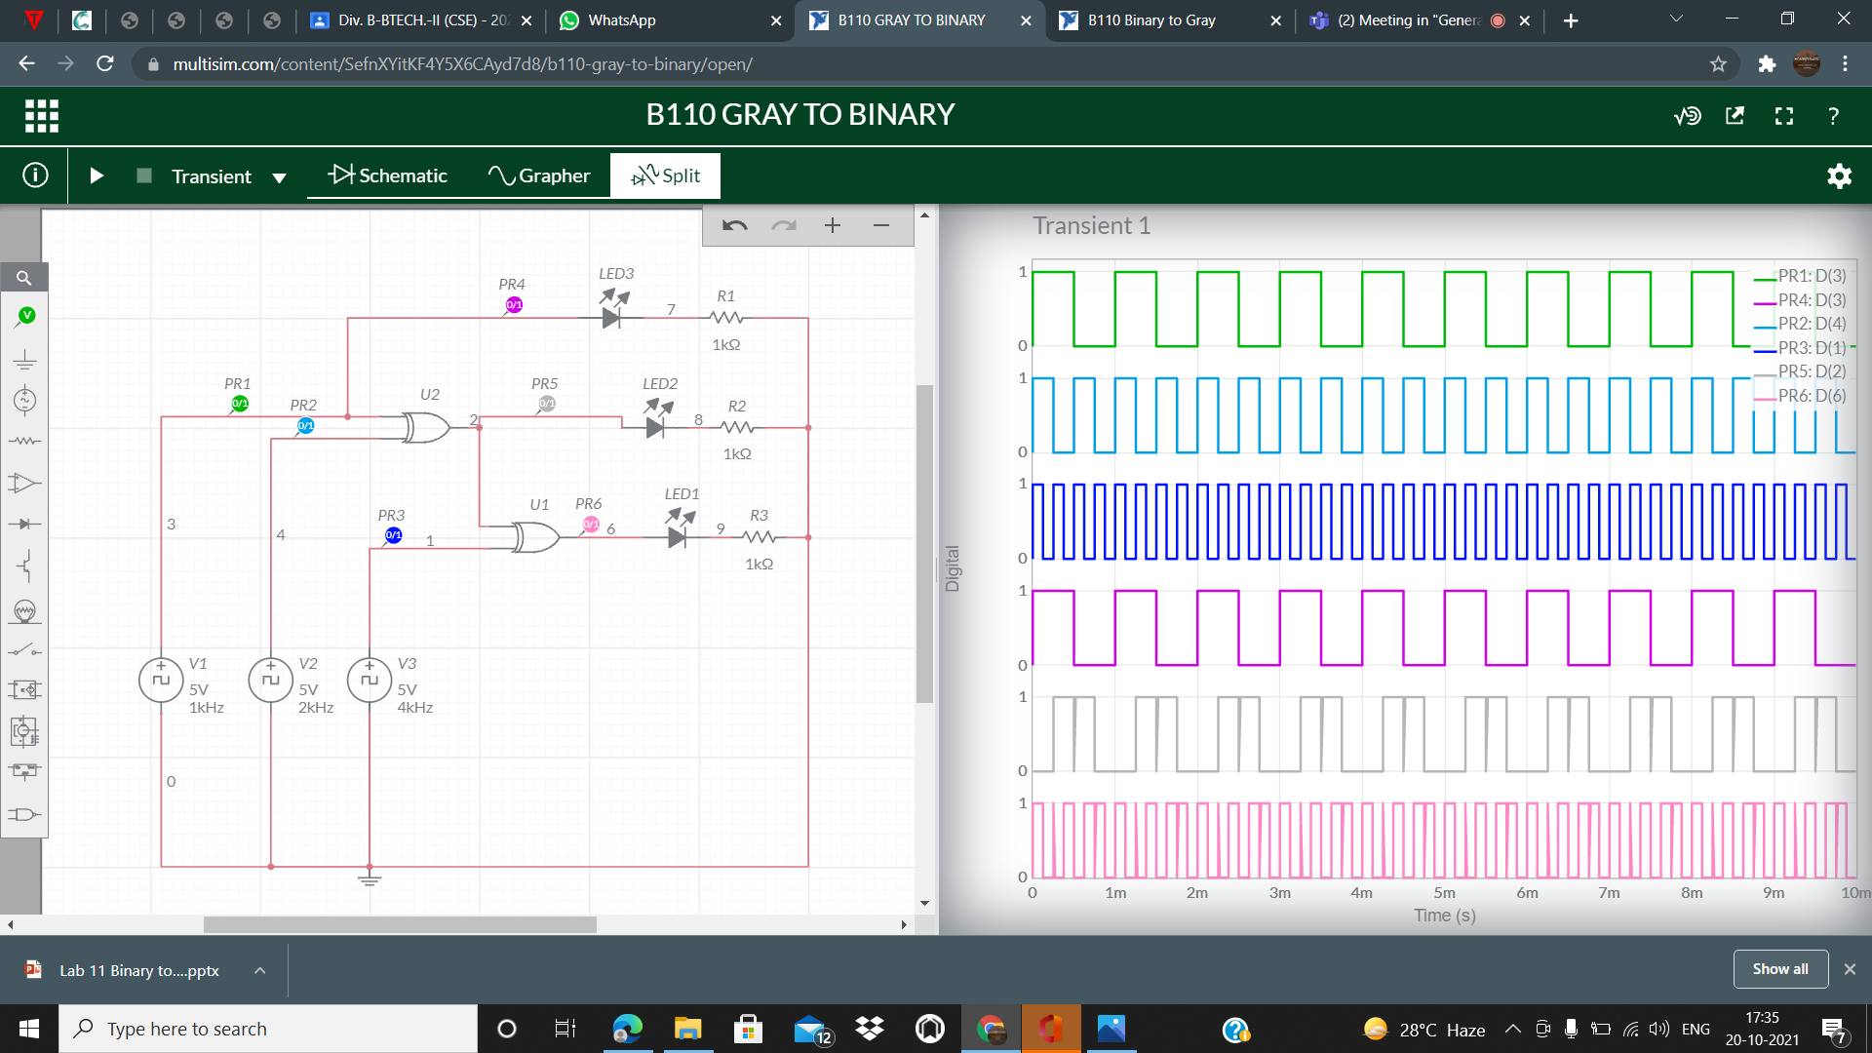

**CIRCUIT/CONNECTION DIAGRAMS (FROM MULTISIM)**

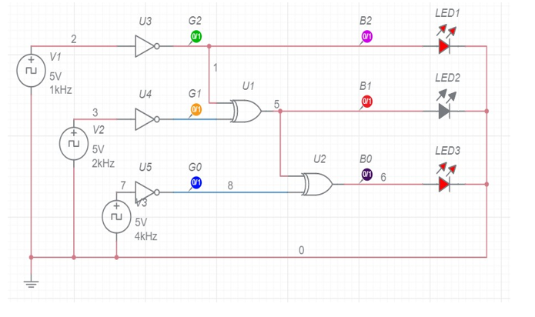

**WAVEFORMS (FROM MULTISIM)**

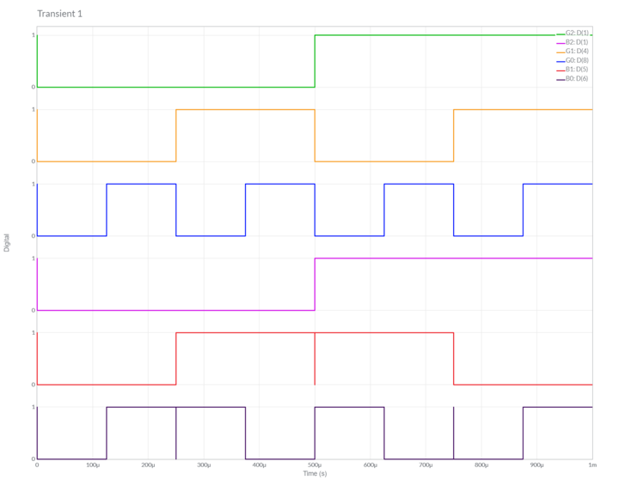

**Conclusions:**

**The truth table in theory and the stimulation of binary to gray and gray to binary code conversion are equal. Hence verified.**